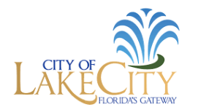

The City of Lake City reopened City Hall on August 2nd, 2021. We have resumed our normal business operations.

Customer Service can be reached at (386)752-2031 or customer.service@lcfla.com Monday through Friday, 8am to 4:30 pm.

